Name: Alfonzo – Rocket
Location: Wine Center/Salazar Quad (LOCATION APPROVED)
Dimensions: 6’ Tall X 3’ Wide
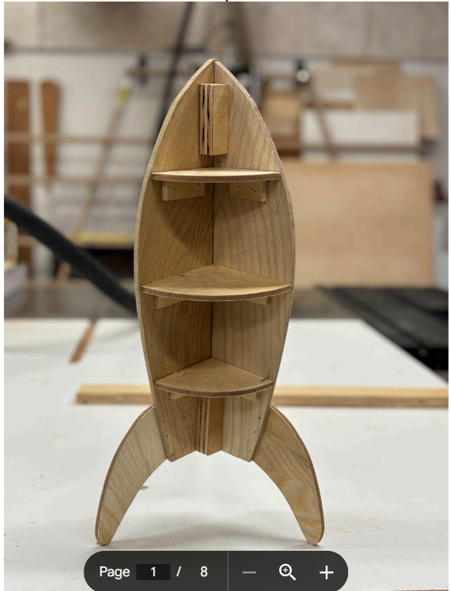
Name: Margaret – Banner: Surface of the Water from Below
Location: Stevenson Stairwell (LOCATION APPROVED)
Dimension: 18’ X 10’
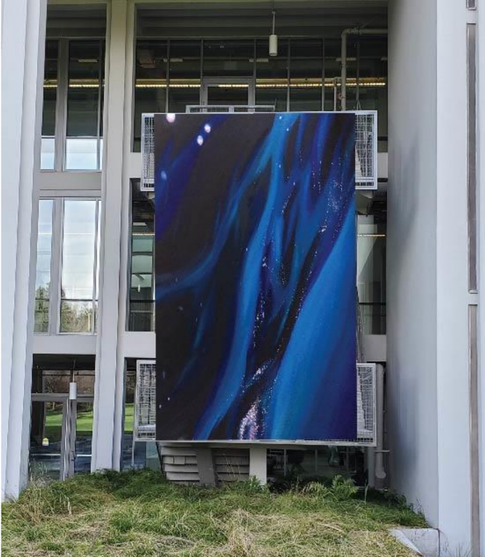

Rick – Sculpture: Monogamy
Location: East Art Building (LOCATION APPROVED)
Dimension: 6’ X base 4’
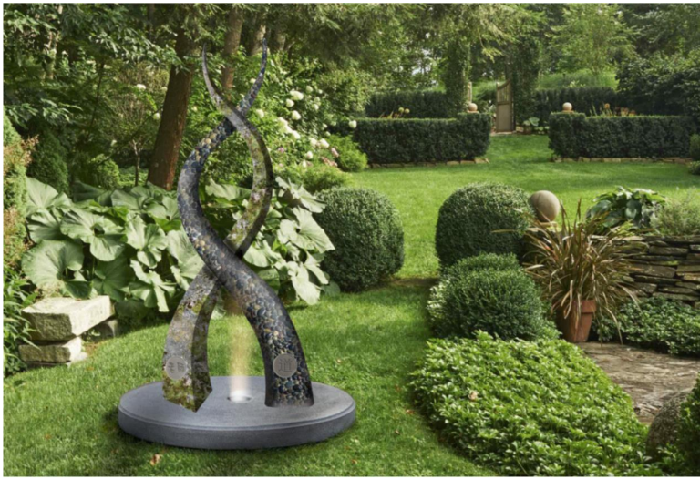

Owen – Airplane Dart
Location: West Stevenson (LOCATION APPROVED)
Dimension: Plane 8’ X 4’ / Mounted high edge 4’
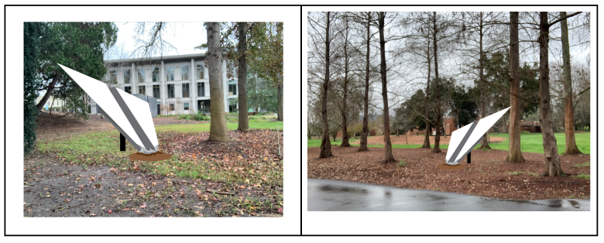

Ash - Octopus
Location: Stevenson (East) (LOCATION APPROVED)
Dimension: 12’ height X 35’ long
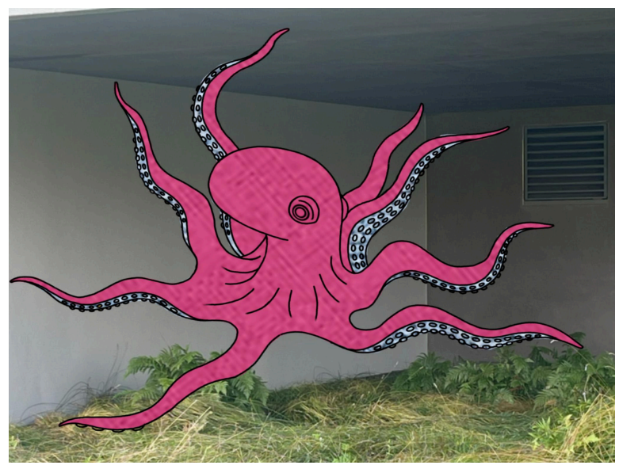

Sophia – Pool Balls & Cue
Location: TBD
Dimension: 2’ diameter (4 to 8 balls total)
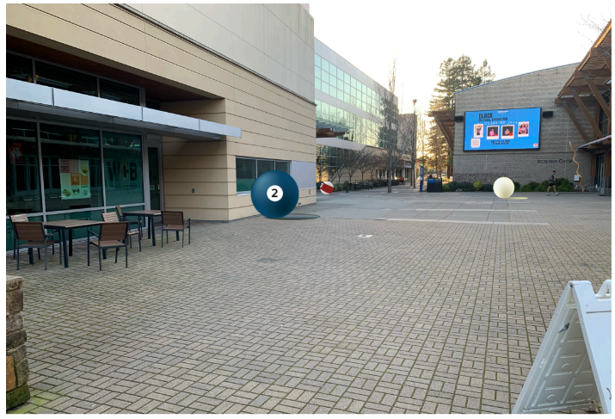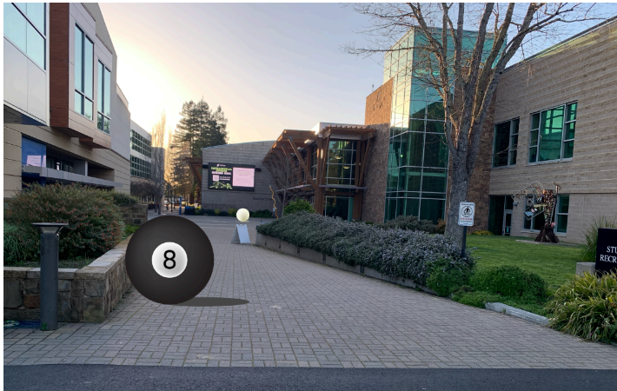
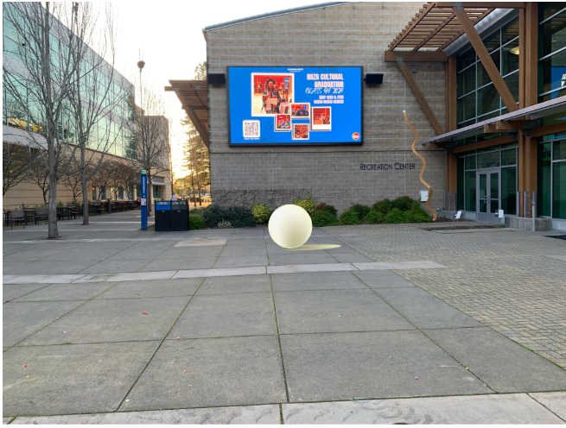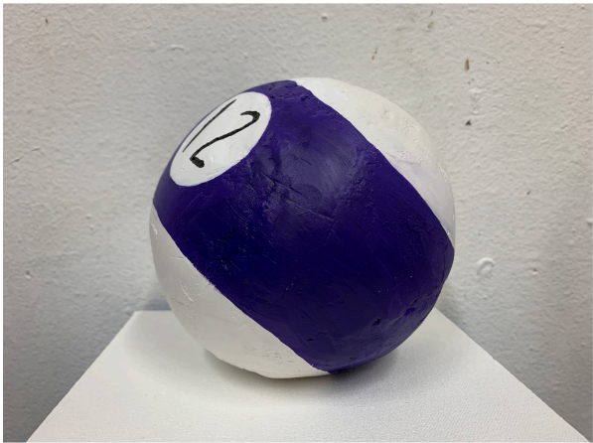

Diane – A Day at the Carousal
Location: Schulz (West) 2nd Floor (LOCATION APPROVED)
Dimension: 6’ Tall X 3’ Wide / Platform 5’ X 7’ with locking wheels
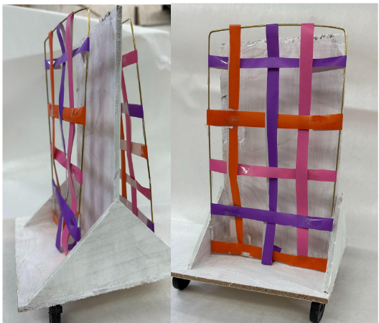

Angela – Bath Tub
Location: Salazar Quad (LOCATION APPROVED)
Dimension: Shower Head 10’ / Tub 4’ X 6’
